**CSS ZEN GARDEN PROJECT**

**Names:**

Joshua Olaoye

Camila Costales

**Theme**: Dark Minimalistic and Modern Design.

* Retro Style
* Static Image for the background
* Overlays to catch the user
* Use of geometric shapes

**Wireframes**:

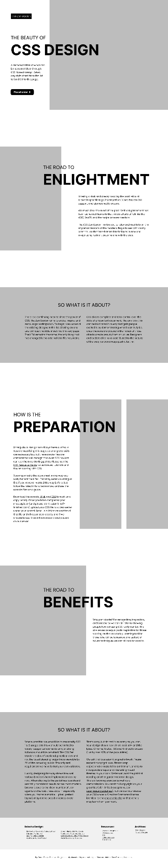

1. 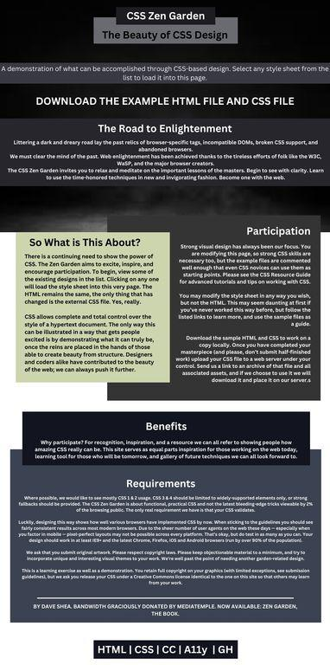

**NB: The first is the web view and the one below is the mobile view.**

